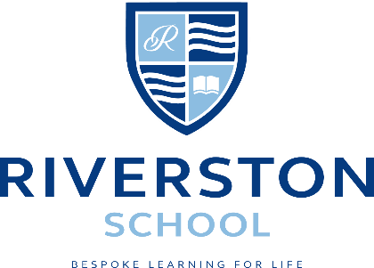

Key Stage 3 Food Technology Teacher (Part-Time)

We are looking for an enthusiastic and committed part-time Food Technology teacher to join our dynamic teaching team in an Independent inclusive school based in Eltham, South-East London.
We work with children of Nursery and Pre-School age and from Year 7 upwards with additional needs including Autism, ADHD, MLD, Downs Syndrome, and social communication and interaction difficulties.
The role includes delivering practical Food Technology lessons to our Key Stage 3 pupils. All lessons take place on a Monday and Tuesday.

Riverston School

Our school has a strong inclusive ethos and has received NAS Accreditation for the outstanding support we provide our students who have Autism (2017). Class sizes are small, with approximately 6-12 pupils per class, which contributes to an effective learning provision.

Salary range: Dependent on qualification and experience
Start Date: As soon as possible or January 2022.
Candidates are requested to email Mrs Aldridge (PA to the Headmaster) at office@riverstonschool.co.uk to receive an application form or Tel: 020 8318 4327.

