Learning about the Size of the Problem

I am learning about the size of the problem.
Some days I may have some problems.
Problems have different sizes.
They can be small, medium or big.

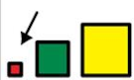
Small problems are problems I can fix myself.
There are some examples of small problems:
- I lost my pen
- I forgot to complete my homework
- Someone jumped in front of me in the que
- I didn’t get to answer the question I out my hand up for
- Someone is kicking my chair in class
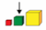
Medium problems are problems adults can help me fix.
There are some examples of medium problems:
- I had an argument with a friend
- Someone is following me around in the play ground
- Someone wants to be my friend and I don’t want to
- Someone is bullying me
- I gave lost my phone.
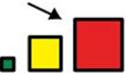
Big problems are problems that the emergency services can help me fix.
There are some examples of big problems:
- A fire at school
- A family member is sick
- I have lost a valuable object
- My bet has died.

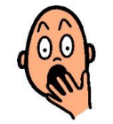
All problems can be scary and make me feel worried.

Big problems are the only problems where I can call the emergency services like the fire brigade, ambulance and police.
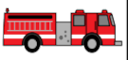
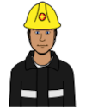

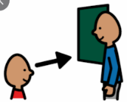
If I am not sure about what size the problem is and how to solve it, I can ask an adult for help.
I am learning about the size of the problem.

